M.Sandeep(192525095)

EXP NO 12: Demonstrate virtualization by Installing Type-2 Hypervisor in your device, create and configure VM image with a Host Operating system (Either Windows/Linux).
Aim:

To demonstrate virtualization by installing and using a Type-2 Hypervisor (VMware Workstation) on a host operating system and creating and configuring a Virtual Machine (VM).

Procedure:
Step 1 – Start VMware Workstation
- Open VMware Workstation in Windows.
- VMware Workstation acts as the Type-2 Hypervisor.
- Click Create a New Virtual Machine. Step 2 – Create the VM
- Select Typical (Recommended).
- Click Next.
- Select the Ubuntu ISO file.
- Click Next.
- Open Terminal and Run Comments.

Implementation:

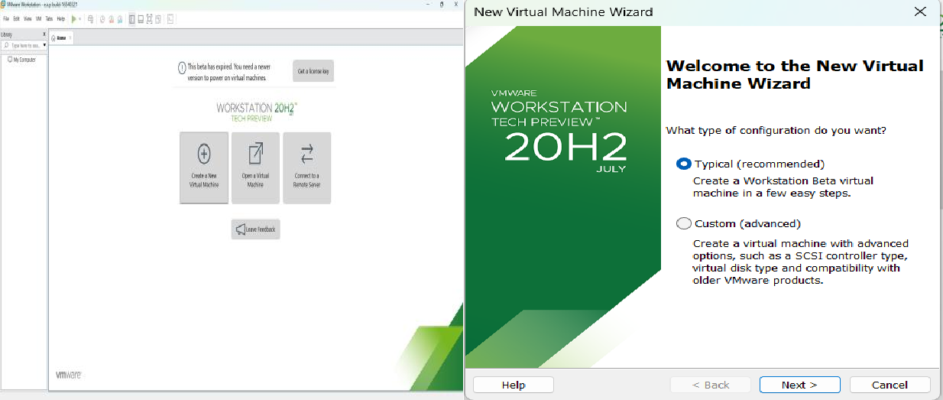

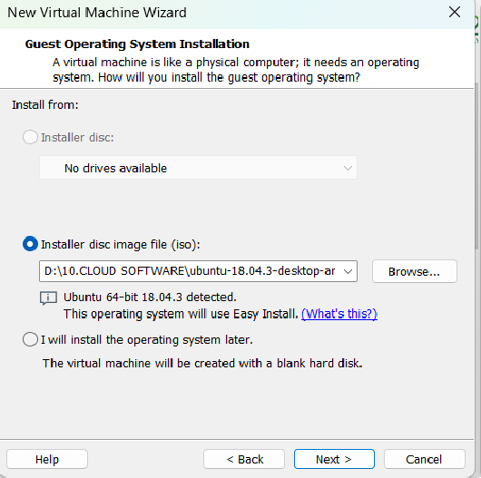

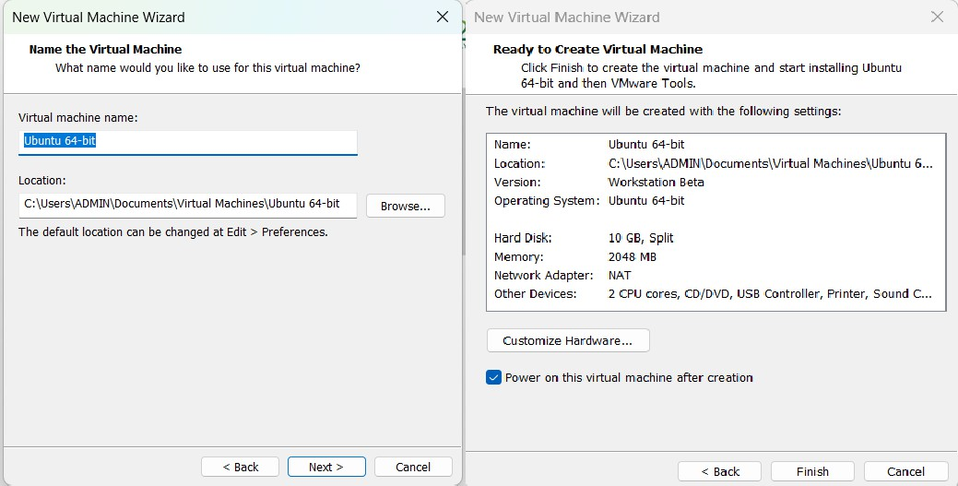

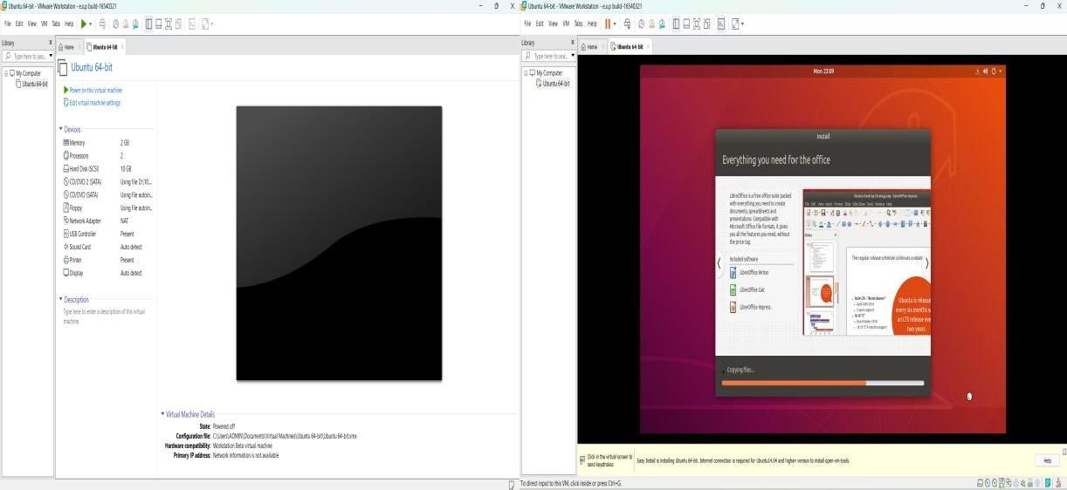

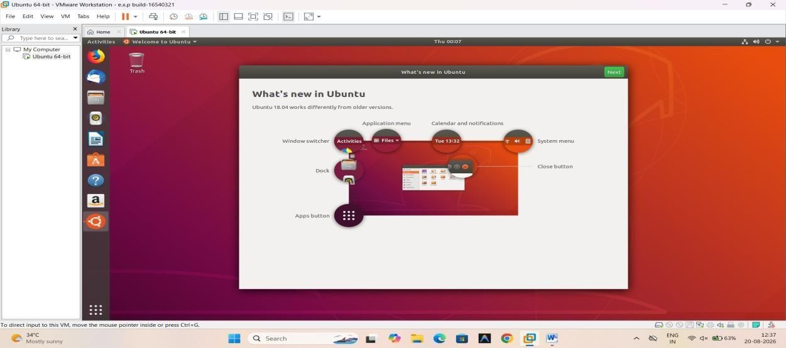
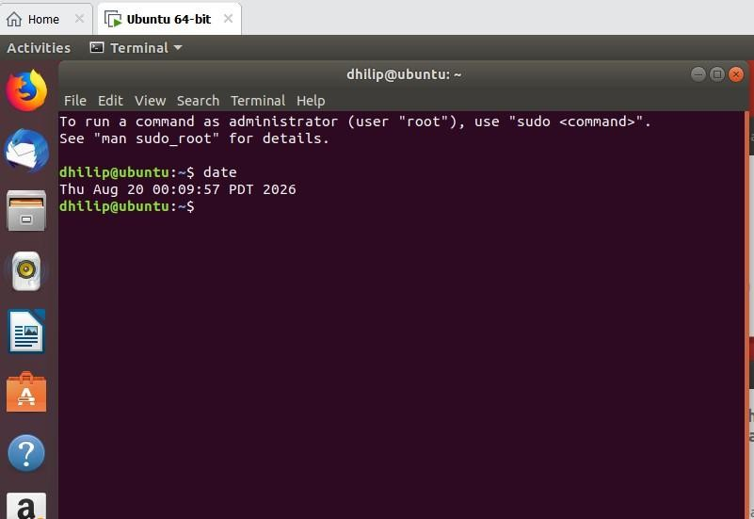

EXP NO 13: Create a Virtual Machine with 1 CPU, 2GB RAM and 15GB storage disk using a Type 2 Virtualization Software.
Aim:

To create a Virtual Machine with 1 CPU, 2 GB RAM, and 15 GB storage disk using a Type 2 virtualization software (VMware Workstation).

Procedure:
Step 1: Open VMware
- Open VMware Workstation.
- Click Create a New Virtual Machine.
- Select Typical (Recommended).
- Click Next.
Step 2: Select Operating System
- Select Installer disc image file (ISO).
- Click Browse.
- Select your Ubuntu ISO file.
- Click Next.
Step 3: Enter VM Information Enter:
  - Full Name: Your name
  - Username: Your preferred username
  - Password: Your preferred password Click Next.
If VMware does not show this screen, you can install Ubuntu normally after creating the VM. Step 4: Give VM Name and Location
For example:

  - Virtual Machine Name: Ubuntu-15GB
  - Location: Choose where you want to store the VM. Click Next.
Step 5: Set Storage

When VMware asks for disk capacity:

  - Maximum disk size: 15 GB

  - Select Store virtual disk as a single file.

Click Next.

Step 6: Set CPU and RAM

Before finishing, click Customize Hardware.

Implementation:
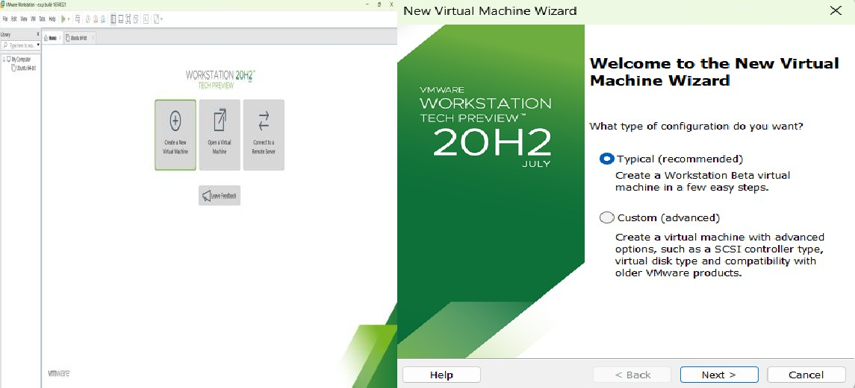

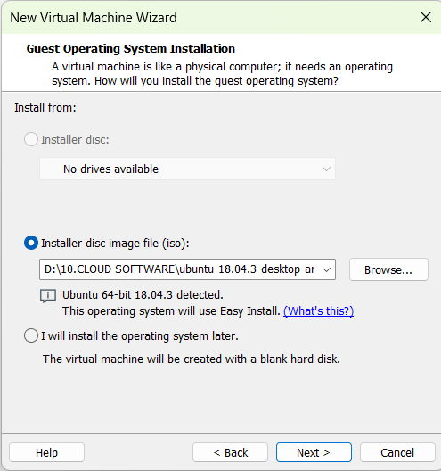

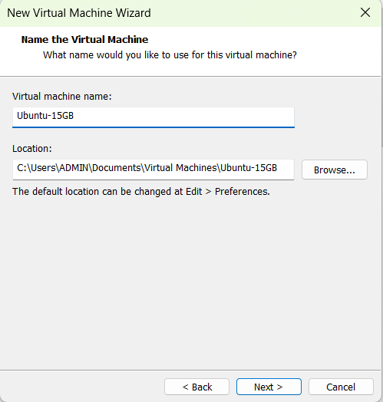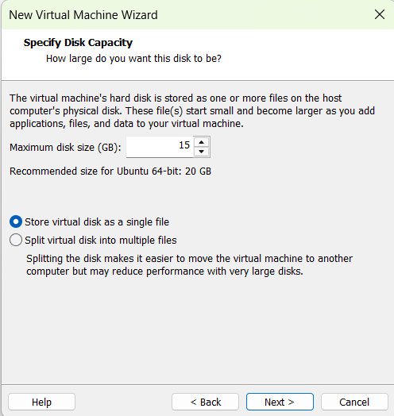

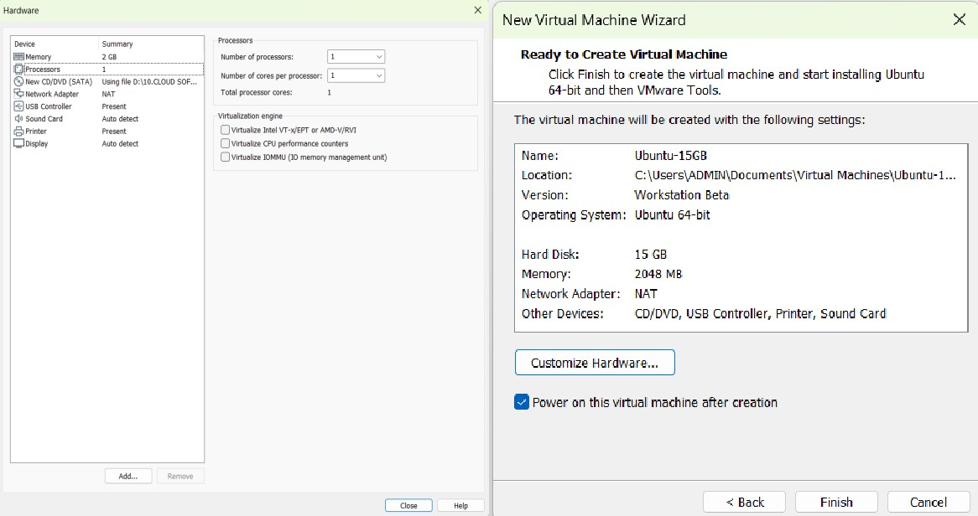

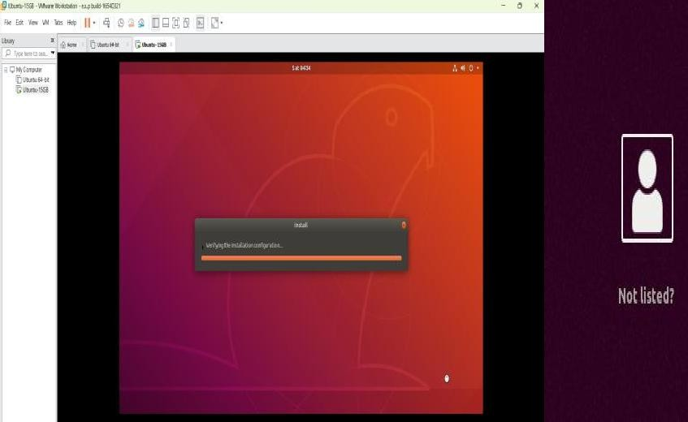

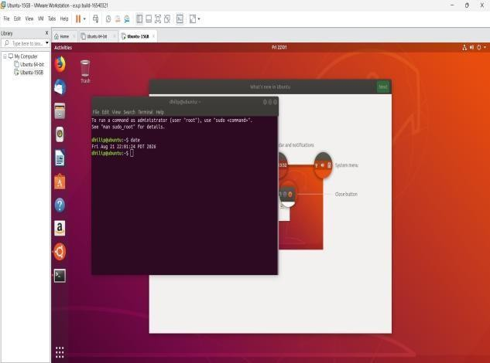

EXP NO 14: Create a Virtual Hard Disk and allocate the storage using VM ware Workstation
Aim:

To create a Virtual Hard Disk and allocate storage to it using VMware Workstation.

Procedure:
- Open VMware Workstation.
- Select your existing Ubuntu VM.
- Make sure the VM is powered off.
- Right-click the VM and select Settings.
- Click Add... at the bottom of the Hardware tab.
- Select Hard Disk.
- Click Next.
- Select the disk type:
- SCSI (recommended/default).
- Click Next.
Select:
Create a new virtual disk. Click Next.
Enter the required disk size. Select:
Click Next.
Give the virtual disk a name, for example:

Click Finish.
Click OK to save the VM setting

Start the Ubuntu VM and open Terminal and run the comments.

Implementation:
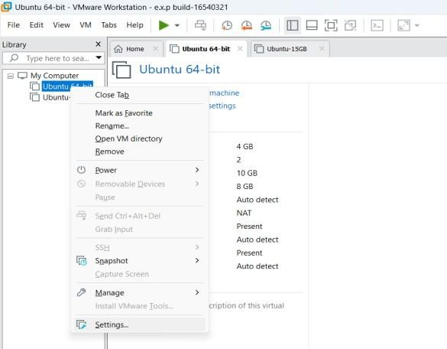
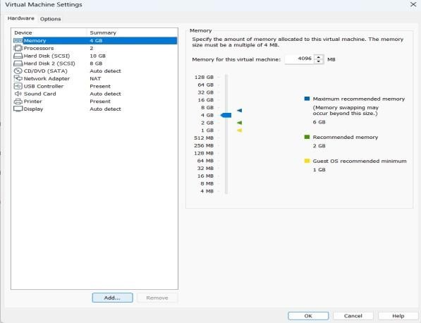
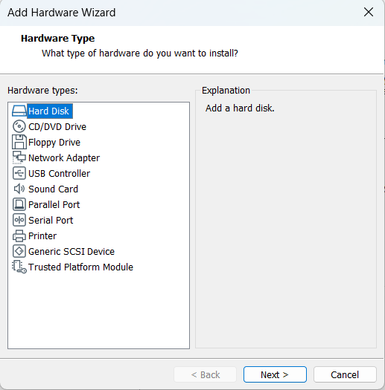
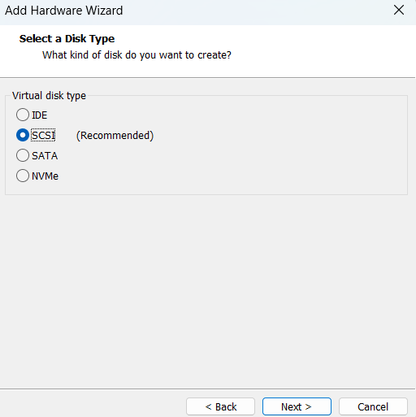

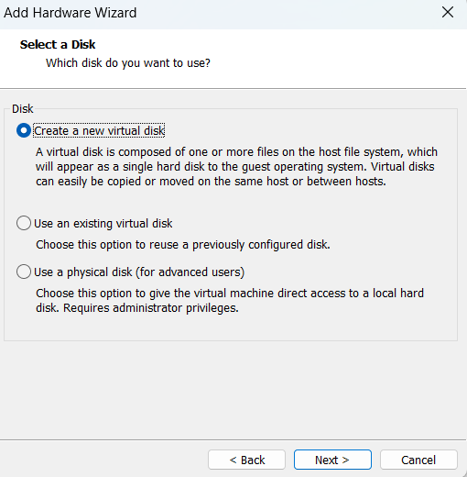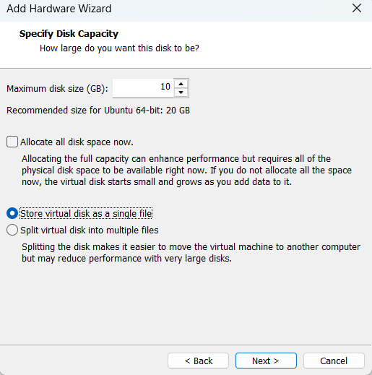
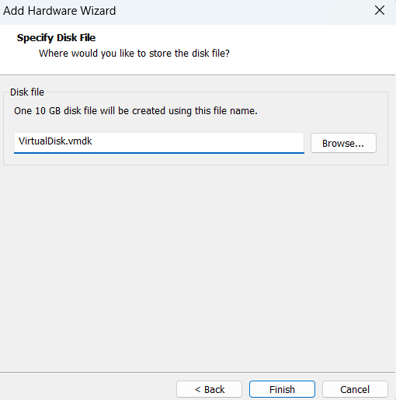
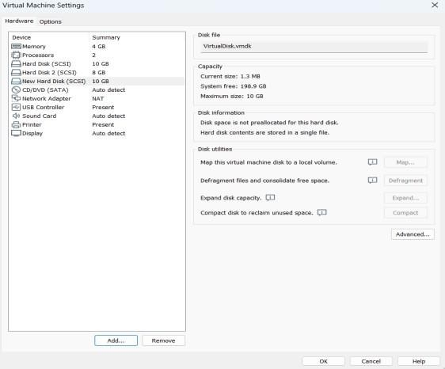
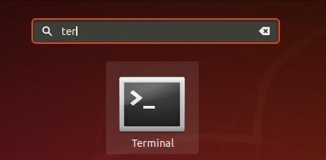

Commend: lsblk
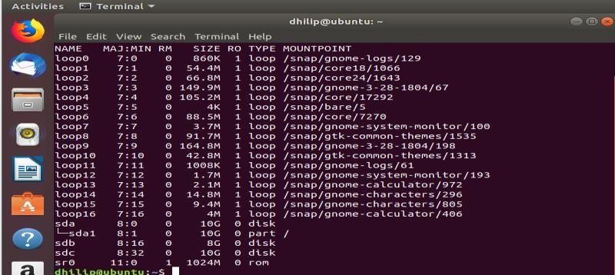

EXP NO 15: Create a Snapshot of a VM and Test it by loading the Previous Version/Cloned VM
Aim:

To create a snapshot of a Virtual Machine using VMware Workstation and test it by restoring the VM to the previous saved state.

Procedure:

Step 1: Start the VM

  - Open VMware Workstation.
  - Select your Ubuntu VM.
  - Start the VM.
  - Wait until Ubuntu loads completely.

Step 2: Create a Snapshot

- In VMware Workstation, select the running Ubuntu VM.
- Go to:

VM → Snapshot → Take Snapshot

- Enter a name:

Before_Test

- You can enter a description such as: Snapshot before making changes
- Click Take Snapshot.

The current state of the VM is now saved. Step 3: Make a Change
Open Ubuntu Terminal and create a test file: touch test_snapshot.txt
Check it:

ls

You should see: test_snapshot.txt

Step 4: Restore the Previous Snapshot

Now restore the VM to the snapshot you created earlier.

- In VMware Workstation, go to: VM → Snapshot → Snapshot Manager
- Select: Before_Test
- Click Go To.
- Confirm the restore operation if VMware asks.

VMware will return the VM to the state when the snapshot was taken. Step 5: Test the Snapshot
After Ubuntu starts again, open Terminal and run: ls
The file: test_snapshot.txt Implementation:
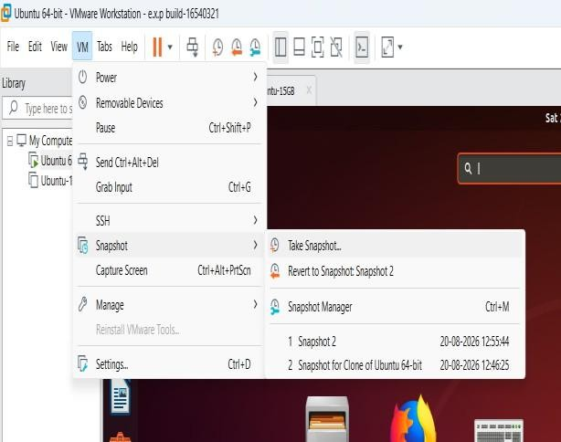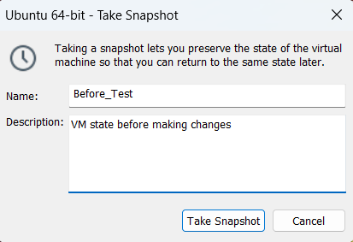

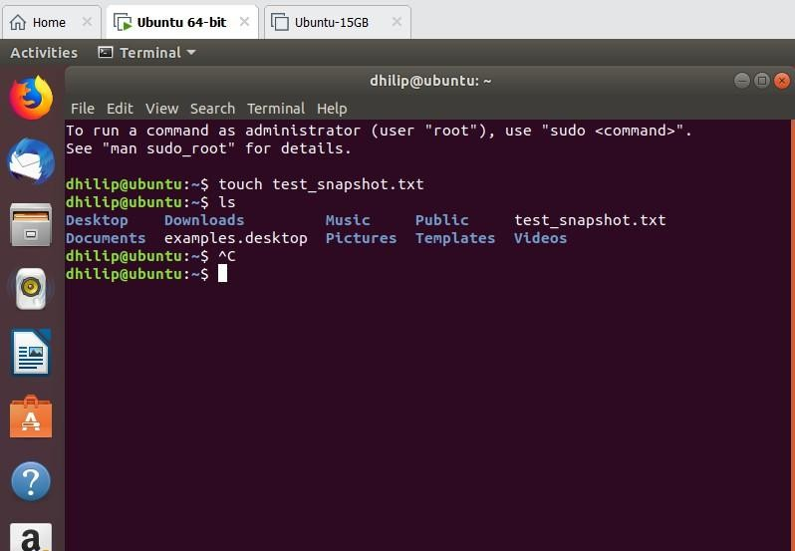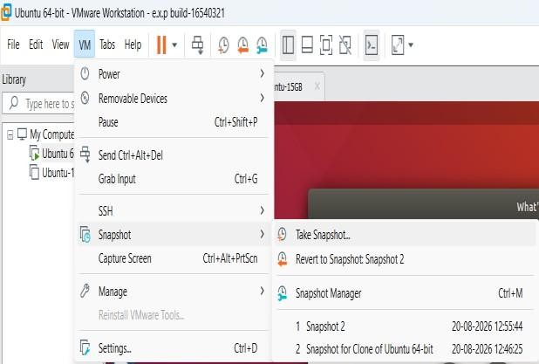
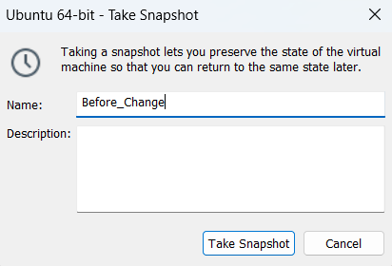
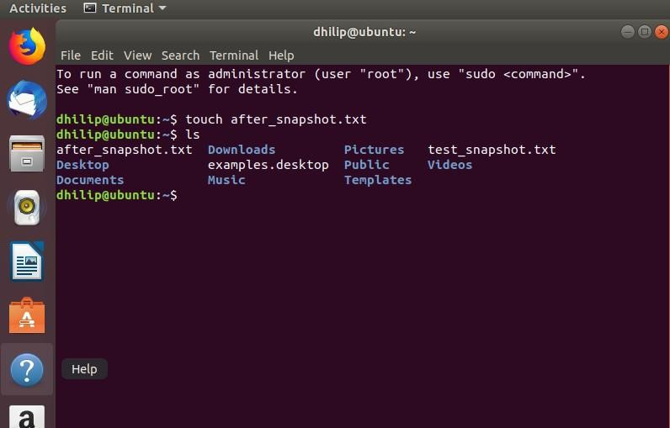
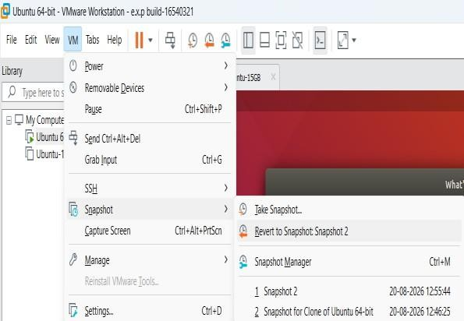
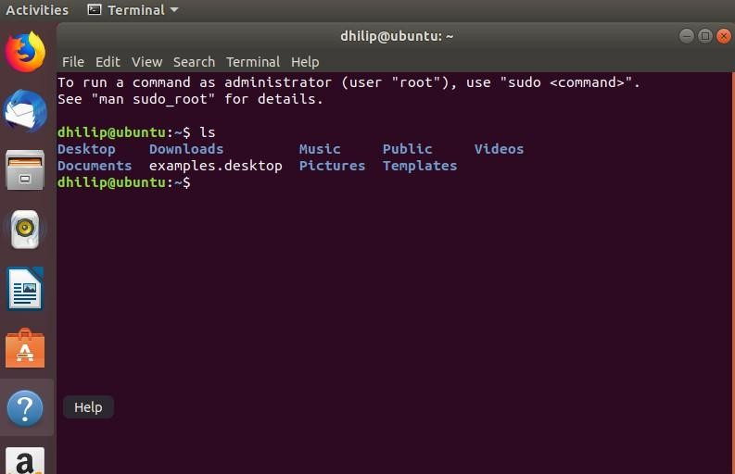

EXP NO 16: Create a Cloning of a VM and Test it by loading the Previous Version/Cloned VM
Aim:

To create a clone of an existing Virtual Machine using VMware Workstation and test the cloned VM by loading and running it successfully.

Requirements:

- VMware Workstation
- An existing Ubuntu/Linux VM
- Sufficient storage space for the cloned VM

Procedure:

Step 1: Power Off the Original VM

- Open VMware Workstation.
- Select your existing Ubuntu VM.
- Make sure the VM is powered off.
  - If it is running, shut down Ubuntu normally.
Step 2: Create the Clone

- Select the original VM.
- Go to:

VM → Manage → Clone

- The Clone Virtual Machine Wizard will open.
- Click Next.
- Select:

The current state in the virtual machine

- Click Next.

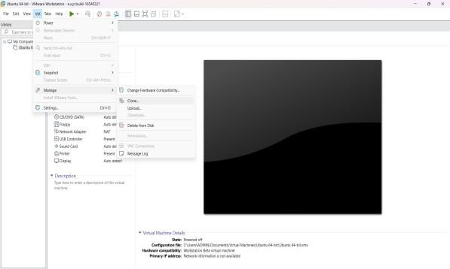
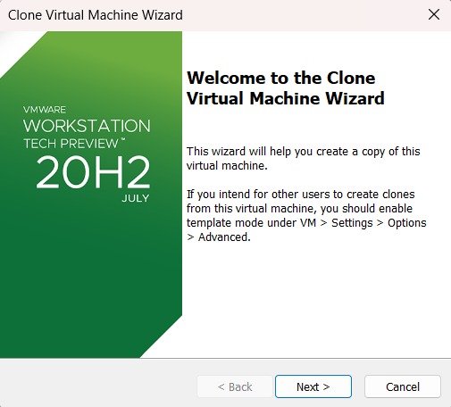

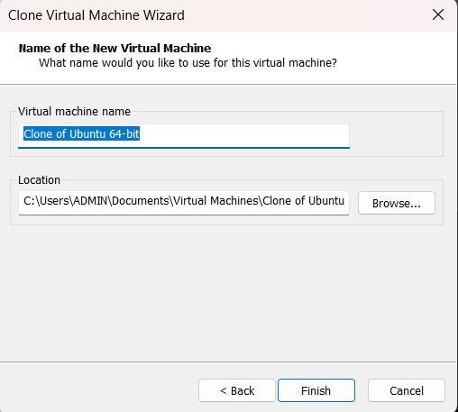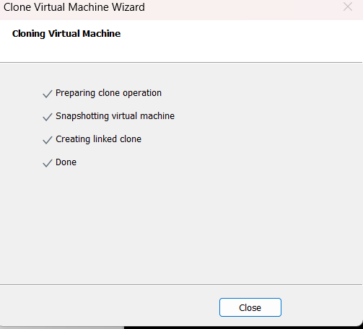

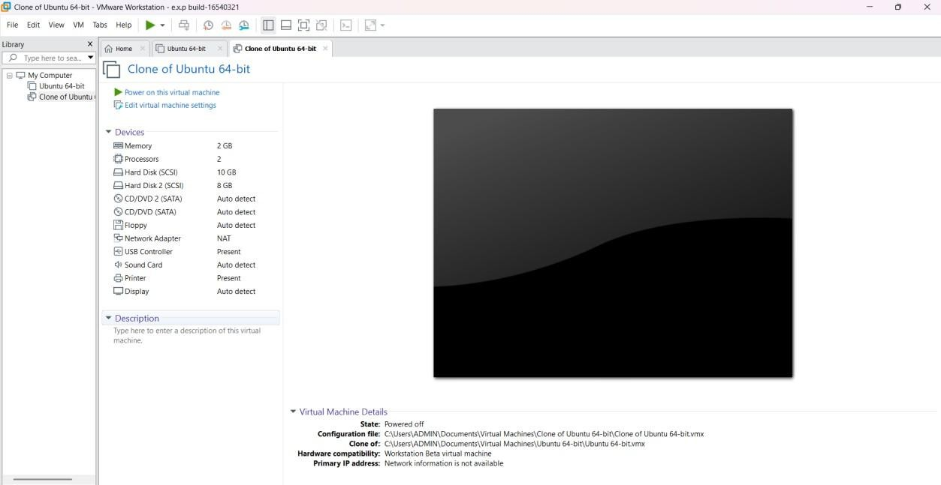

EXP NO 17: Change Hardware compatibility of a VM (Either by clone/create new one) which is already created and configured and run simple unix commands

Aim:

To change the hardware compatibility of an already created and configured virtual machine in VMware Workstation and verify the VM by running simple UNIX commands.

Procedure:

Step 1: Open VMware Workstation

- Open VMware Workstation in Windows.
- Select your already created Ubuntu VM.
- Do not start the VM.
- Make sure the Ubuntu VM is powered off.

Step 2: Open Virtual Machine Settings

- Select the Ubuntu VM.
- Click VM from the top menu.
- Select Manage.
- Click Change Hardware Compatibility.

Step 3: Select Hardware Compatibility

- A Change Hardware Compatibility Wizard will open.
- Click Next.
- VMware will display the current hardware compatibility version.
- Select a newer hardware compatibility version available in your VMware Workstation.
- Click Next.

Example: If your current version is older, select the latest compatible version offered by your VMware Workstation.

Step 4: Choose the Conversion Option

- VMware may ask whether to:
  - Create a new virtual machine, or
  - Change the existing virtual machine.
- Select the appropriate option for the existing VM.
- Click Next.

Step 5: Complete the Hardware Compatibility Change

- Review the settings.
- Click Finish.
- Wait until VMware completes the hardware compatibility change.

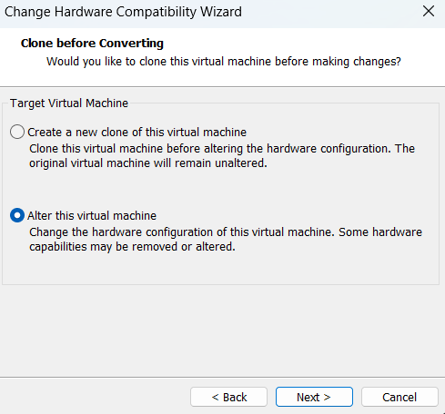
- The VM's hardware compatibility has now been changed.

Step 6: Start the Ubuntu VM

  - Select the modified Ubuntu VM.
  - Click Power on.
  - Wait for Ubuntu to boot completely.

Step 7: Open Terminal

Open the Ubuntu Terminal using: Ctrl + Alt + T
Step 8: Run Simple UNIX Commands

Run the following commands one by one.

1. Display current user:

Whoami

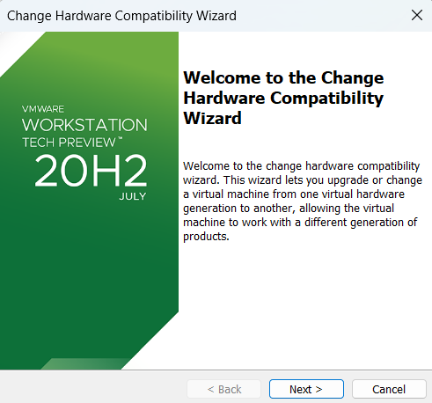
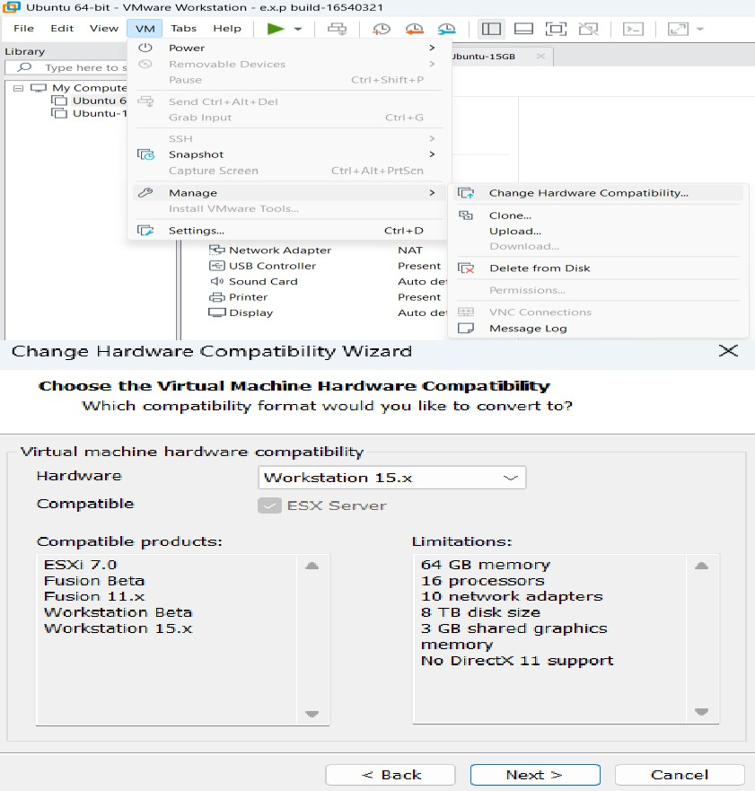
Implementation:

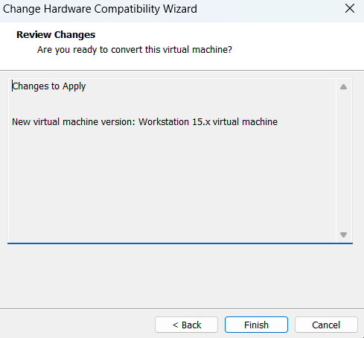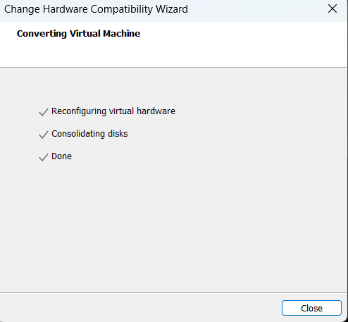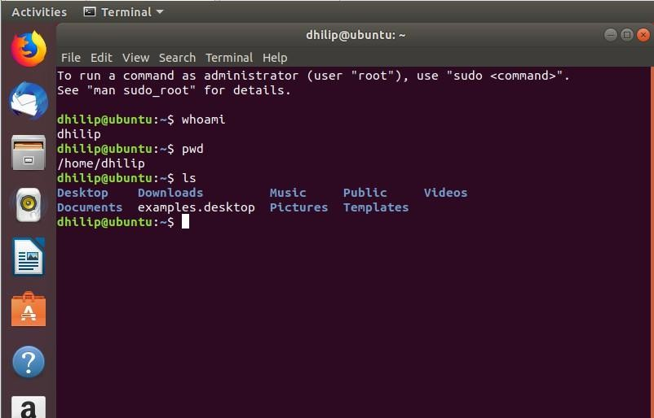
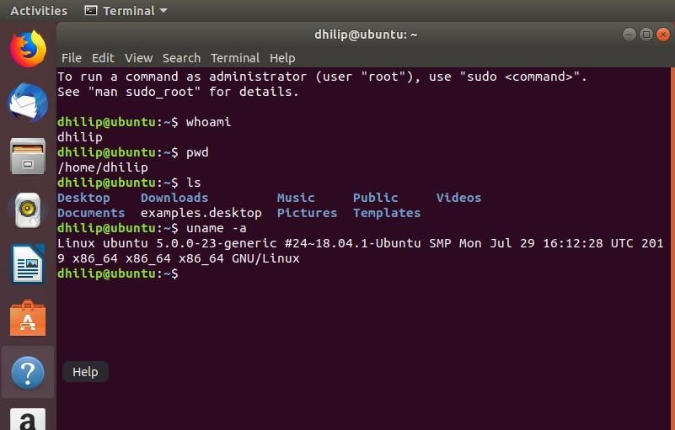

EXP NO 18: Install Virtualbox/VMware Workstation with different flavours of linux or windows OS on top of your present windows environment.

Aim:

To install VMware Workstation and create virtual machines with different operating systems such as Ubuntu Linux on the existing Windows environment.

Procedure:
Step 1: Open VMware Workstation

- Open VMware Workstation in Windows.
- Click Create a New Virtual Machine.

Step 2: Select Installation Method

- Select Typical (recommended).
- Click Next.

Step 3: Select the Operating System ISO

- Select Installer disc image file (ISO).
- Click Browse.
- Select the Linux/Windows ISO file.
- Click Next.

Example:

Ubuntu ISO → ubuntu.iso

Step 4: Select Operating System

- Select the appropriate operating system.
- For Ubuntu, select:

Linux Ubuntu 64-bit

- Click Next.

Step 5: Give Virtual Machine Name Enter a name such as:
Ubuntu-VM

Select a location where you want to store the VM.

Click Next.

Step 6: Configure Disk

- Specify the disk size.

For example:

20 GB

- Select Store virtual disk as a single file.
- Click Next.

Step 7: Customize Hardware Click Customize Hardware. Configure:
  - Memory: 2 GB or more
  - Processor: 2 cores
  - Network Adapter: NAT

Click Close → Finish.

Step 8: Install the Operating System

- Start the virtual machine by clicking Power on this virtual machine.
- The operating system installer will start.
- Follow the installation instructions.
- Create a username and password when requested.
- Wait for the installation to complete.

Step 9: Restart the Virtual Machine After installation:
- Restart the VM.
- Remove the ISO if VMware asks you to do so.
- Ubuntu will boot from the virtual hard disk.

Step 10: Verify the Installation

Open the Terminal in Ubuntu and run: uname -a
Then: ls

And Pwd

Implementation:
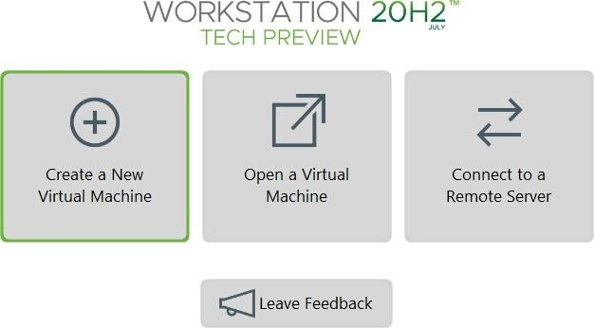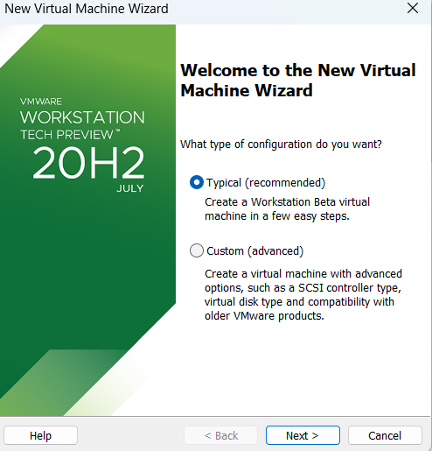

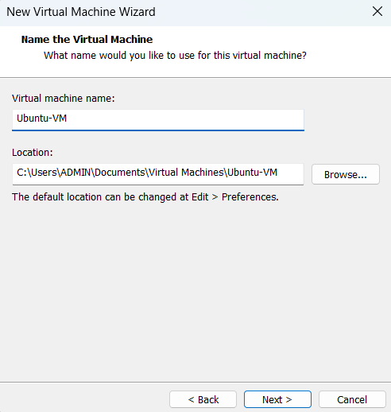
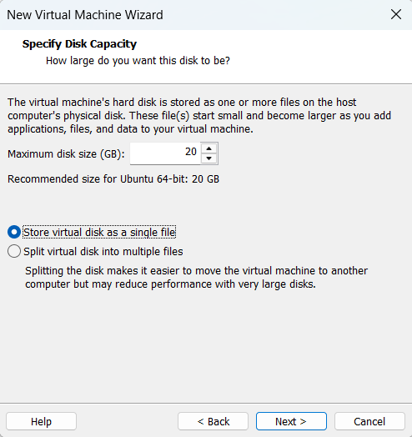
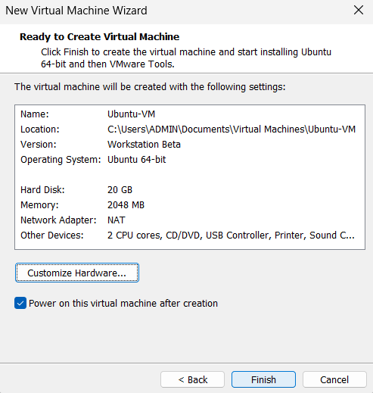

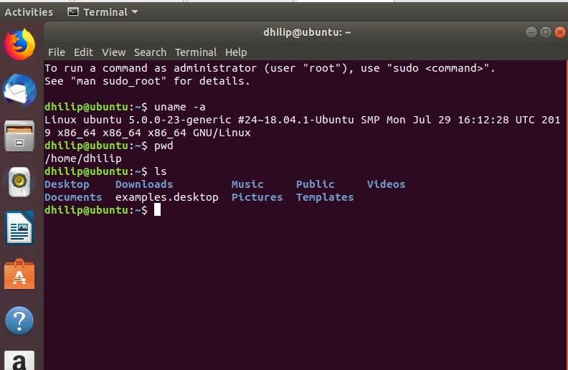
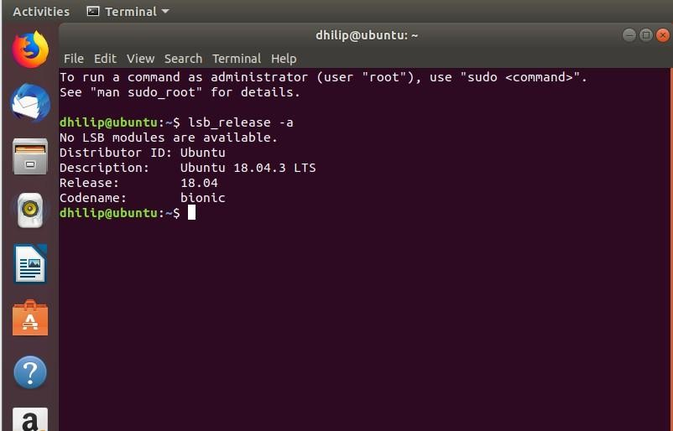

EXP NO 19: Install a C compiler in the virtual machine created using virtual box / VM Ware Workstation / Player and execute Simple C Programs.

Aim:

To install a C compiler (GCC) in the Ubuntu virtual machine created using VMware Workstation and execute a simple C program.

Procedure:

Step 1: Start Ubuntu VM

- Open VMware Workstation.
- Start your Ubuntu VM.
- Login to Ubuntu.

Step 2: Open Terminal Press:
Ctrl + Alt + T

Step 3: Update the Package List Type:
sudo apt update Press Enter.
Enter your Ubuntu password when asked.
While typing the password, you won't see any characters. This is normal. Type the password and press Enter.

Wait until the update finishes. Step 4: Install GCC Compiler Type:
sudo apt install gcc If it asks:
Do you want to continue? [Y/n] Type:

Y

and press Enter.

Wait for the installation to complete. Step 5: Check GCC Installation Type:
gcc --version

You should see something similar to: gcc (Ubuntu ...) ...
This confirms that the C compiler is installed.

Step 6: Create a C Program Create a file named hello.c: nano hello.c
The Nano editor will open.

Type this program:
#include <stdio.h> int main()
{
printf("Hello World!\n"); return 0;
}

Step 7: Save the Program In Nano:
- Press Ctrl + O
- Press Enter
- Press Ctrl + X

You will return to the terminal. Step 8: Compile the C Program Type:

gcc hello.c -o hello

If there is no error message, compilation was successful. Step 9: Execute the Program
Type:

./hello

Expected output: Hello World!

Implementation:
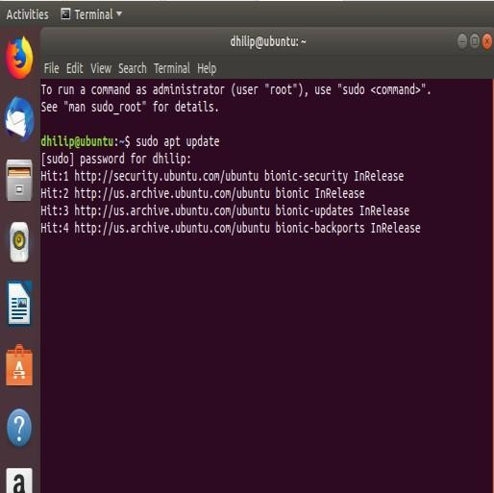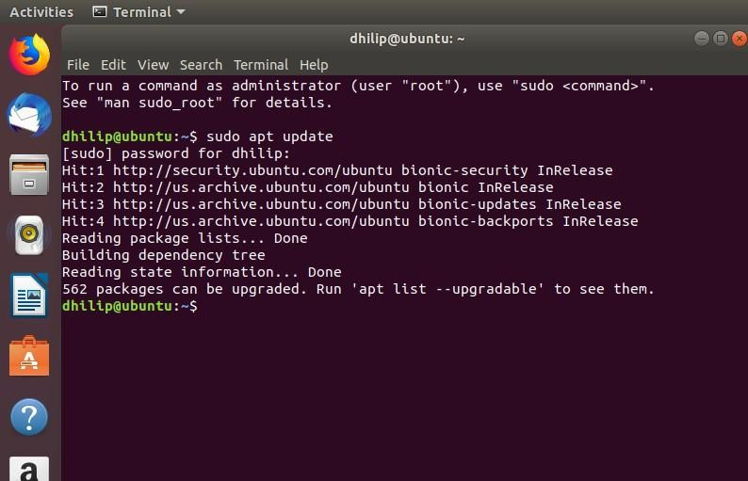
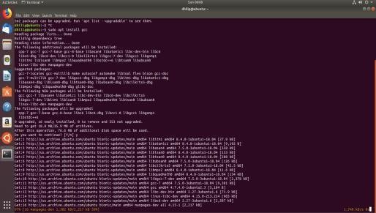
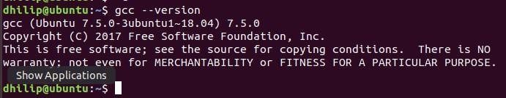
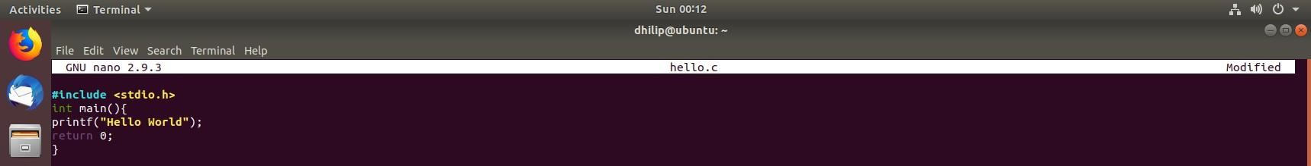
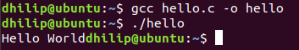

EXP NO 20: Install Virtualbox with different flavours of linux or windows OS on top of windows 10 using custom installation.

Aim:
To install Oracle VirtualBox on Windows 10 and install a different flavour of Linux/Windows operating system using Custom Installation.

Procedure:

Step 1: Open VirtualBox

- Open Oracle VM VirtualBox on your Windows computer.
- Click New to create a new virtual machine.

Step 2: Create the Virtual Machine

- Enter the VM name, for example: Ubuntu-VirtualBox
- Select the location where you want to store the VM.
- Select the ISO Image of Ubuntu.
- Select the operating system type:
  - Type: Linux
  - Version: Ubuntu (64-bit)
- Click Next.

Step 3: Select Custom Installation

When VirtualBox provides the installation options, choose the option for custom/unattended installation settings as applicable.

If you see Skip Unattended Installation, select it if you want to perform the OS installation manually.

Click Next.

Step 4: Configure Hardware Set the hardware resources: Memory:
2048 MB (2 GB)

Processors:

2 CPUs

Click Next.

Step 5: Create Virtual Hard Disk

- Select Create a Virtual Hard Disk Now.
- Set the disk size to: 20 GB
- Click Next.
- Review the configuration.
- Click Finish.

Step 6: Start the Virtual Machine

- Select Ubuntu-VirtualBox.
- Click Start.
- Ubuntu will boot from the selected ISO file.

Step 7: Install Ubuntu

When the Ubuntu installer appears:

- Select Install Ubuntu.
- Select the keyboard layout.
- Choose the installation type.
- Select Erase disk and install Ubuntu.

This refers to the virtual hard disk, not your actual Windows C: drive.

- Set your location/time zone.
- Create a username and password.
- Click Install.
- Wait for the installation to complete.

Step 8: Restart the VM After installation:
- Click Restart Now.
- If VirtualBox asks you to remove the installation medium, press Enter.
- Ubuntu will restart.
- Login using the username and password you created.

Step 9: Verify the Installation Open Terminal:

Run: lsb_release –a

Implementation:
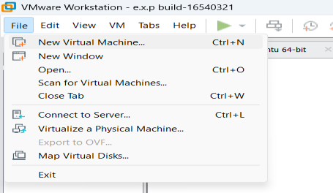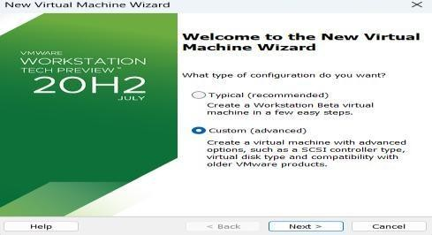
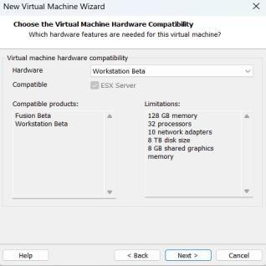
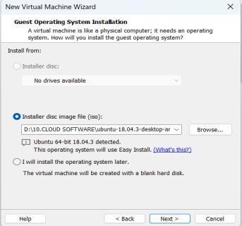
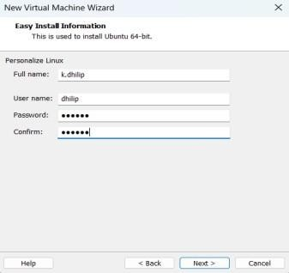
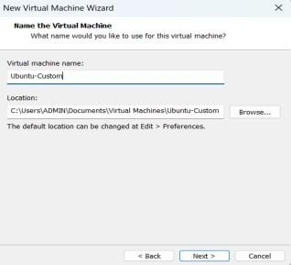
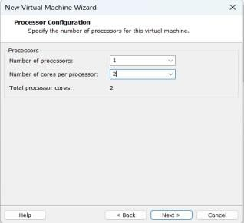
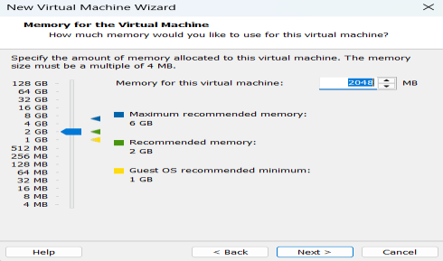
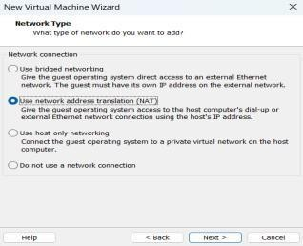
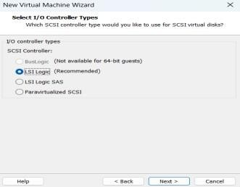
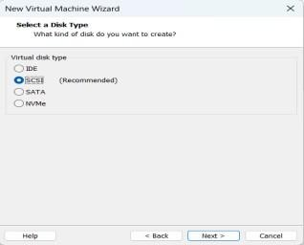
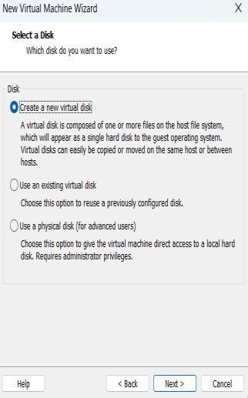
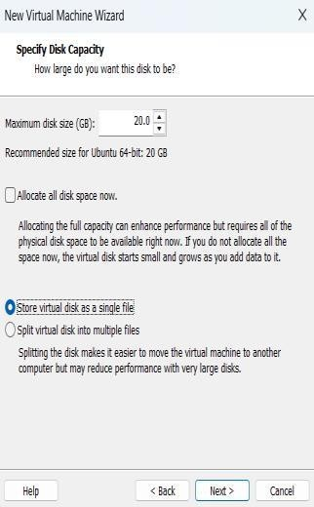
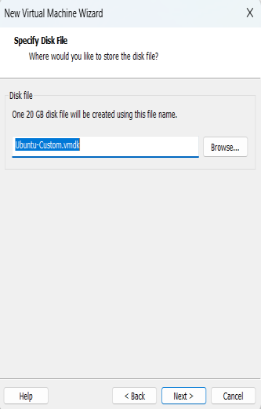

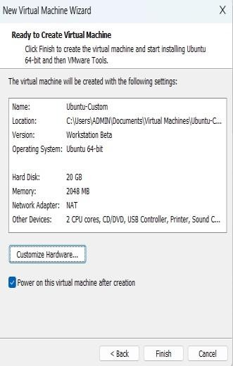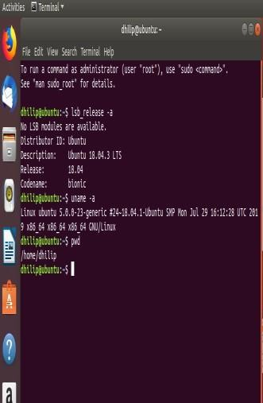

EXP NO 21: Install Virtualbox/VMware Workstation with different flavours of linux or windows OS on top of windows 7 or 8.

Aim:
To install VMware Workstation and create virtual machines with different operating systems such as Ubuntu Linux on the existing Windows environment.

Procedure:

Step 1: Open VMware Workstation

- Open VMware Workstation in Windows.
- Click Create a New Virtual Machine.

Step 2: Select Installation Method

- Select Typical (recommended).
- Click Next.

Step 3: Select the Operating System ISO

- Select Installer disc image file (ISO).
- Click Browse.
- Select the Linux/Windows ISO file.
- Click Next.

Example:

Ubuntu ISO → ubuntu.iso

Step 4: Select Operating System

- Select the appropriate operating system.
- For Ubuntu, select:

Linux Ubuntu 64-bit

4. Click Next.

Step 5: Give Virtual Machine Name Enter a name such as:
Ubuntu-VM

Select a location where you want to store the VM. Click Next.
Step 6: Configure Disk

2. Specify the disk size.

For example:

20 GB

- Select Store virtual disk as a single file.
- Click Next.

Step 7: Customize Hardware Click Customize Hardware. Configure:
  - Memory: 2 GB or more
  - Processor: 2 cores
  - Network Adapter: NAT

Click Close → Finish.

Step 8: Install the Operating System

- Start the virtual machine by clicking Power on this virtual machine.
- The operating system installer will start.
- Follow the installation instructions.
- Create a username and password when requested.
- Wait for the installation to complete.

Step 9: Restart the Virtual Machine After installation:

- Restart the VM.
- Remove the ISO if VMware asks you to do so.
- Ubuntu will boot from the virtual hard disk.

Step 10: Verify the Installation

Open the Terminal in Ubuntu and run: uname -a
Then:

ls And:
Pwd

Implementation:









EXP NO 22: To write a procedure to run the virtual machine of different configuration and to check how many virtual machines can be utilized at a particular time.

Aim:
To run virtual machines with different hardware configurations in VMware Workstation and determine how many virtual machines can be utilized simultaneously on the host computer.

Procedure:

Step 1 — Open VMware Workstation

- Open VMware Workstation Pro.
- Make sure your previously created Ubuntu VMs are available.

Step 2 — Check the Host Computer Resources

Before starting multiple VMs, check your Windows computer's:

  - RAM
  - CPU
  - Available disk space

You can check RAM and CPU using:

Task Manager → Performance

Step 3 — Configure the First VM

For example, configure Ubuntu VM 1 with:

RAM: 2 GB
CPU: 1 processor, 2 cores Start the VM.
Step 4 — Configure the Second VM Create/select another VM and configure it with:
RAM: 2 GB
CPU: 1 processor, 2 cores

Start the second VM without shutting down the first VM. Step 5 — Configure Additional VMs
If your computer has sufficient resources, start another VM. For example:
VM 1 → 2 GB RAM
VM 2 → 2 GB RAM
VM 3 → 2 GB RAM

Do not start more VMs if the host system becomes very slow or runs out of memory. Step 6 — Check Running Virtual Machines
In VMware Workstation, observe which VMs are powered on. You can also check Windows:
Task Manager → Performance → Memory / CPU Observe the resource usage while the VMs are running. Step 7 — Test Each VM
Open the Terminal in each running Ubuntu VM and execute: uname -a
and: pwd

If the commands execute successfully, the VMs are running correctly. Step 8 — Determine the Maximum Number
Start the VMs one by one. After starting each VM, check:
  - CPU usage
  - RAM usage
  - System responsiveness
  - Whether the VM operates normally

The maximum number of VMs is the number that can run simultaneously while the host and VMs remain usable.

Example

If your computer has 8 GB RAM, you might test:
VM 1 → 2 GB
VM 2 → 2 GB
VM 3 → 2 GB

Implementation:
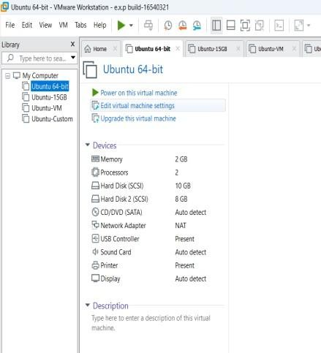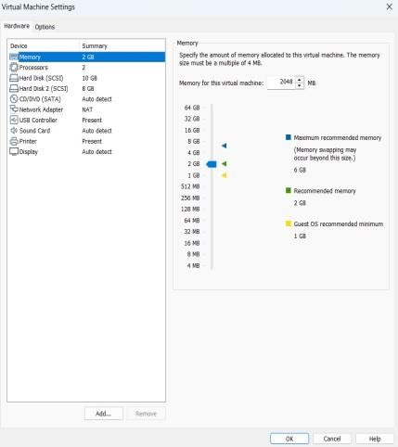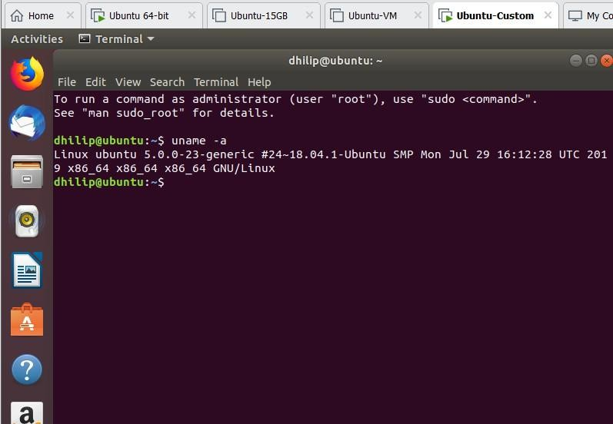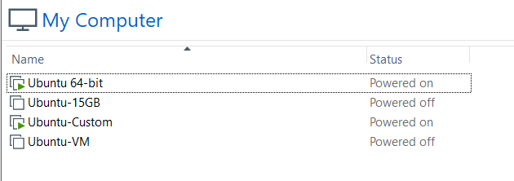

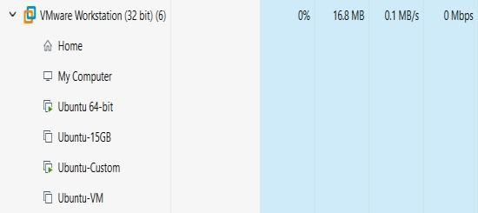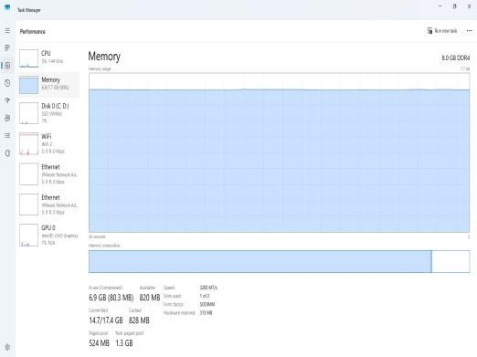

EXP NO 23: Write a Procedure To Attach Virtual Block To The Virtual Machine And Check Whether It Holds the Data Even After The Release Of The Virtual Machine

Aim:
To attach a virtual block (virtual hard disk) to a virtual machine and verify whether the data stored on it remains available even after the virtual machine is released or powered off.

Procedure:
We will use your Ubuntu VM in VMware Workstation Pro. Step 1 — Power Off the VM
- Open VMware Workstation Pro.
- Select your Ubuntu VM.
- Shut down Ubuntu completely.
- Make sure the VM shows Powered Off.

Do not suspend it. It should be completely powered off. Step 2 — Open Virtual Machine Settings
- Select the Ubuntu VM.
- Click Edit virtual machine settings.
- The Virtual Machine Settings window will open.

Step 3 — Add a Virtual Hard Disk

- Click Add...
- Select: Hard Disk
- Click Next.

Step 4 — Select Disk Type

Select:

SCSI

Then click Next.

Step 5 — Create a New Virtual Disk Select:
Create a new virtual disk Click Next.
Step 6 — Set Disk Size Enter:
1 GB
You can use 1 GB because we only need a small disk for this experiment. Select:
Store virtual disk as a single file Click Next.
Step 7 — Finish Adding the Disk Leave the disk filename as the default. Click:
Finish Then click:
OK
The new virtual hard disk is now attached to your Ubuntu VM. Step 8 — Start Ubuntu
Power on the Ubuntu VM. Open Terminal:
Ctrl + Alt + T

Step 9 — Check the New Virtual Disk Run:
lsblk
You should see your original disk and a new disk, for example: sda
├─sda1
└─sda2
sdb

The newly added disk will usually appear as sdb. Do not format sda. That is your Ubuntu system disk. Step 10 — Create a Partition
If the new disk is /dev/sdb, run:

sudo fdisk /dev/sdb Inside fdisk:
Press:

n

Press Enter.

Then press Enter for the default partition options until the partition is created. Finally press:
w

This saves the partition.

Step 11 — Format the Partition Run:
sudo mkfs.ext4 /dev/sdb1

This creates an ext4 filesystem on the new virtual disk. Step 12 — Create a Mount Directory
Run:

sudo mkdir /mnt/virtualdisk

Step 13 — Mount the Virtual Disk Run:
sudo mount /dev/sdb1 /mnt/virtualdisk Check:
df -h

You should see /mnt/virtualdisk.

Step 14 — Create Data on the Virtual Block Create a file:
sudo touch /mnt/virtualdisk/test_data.txt Put some text into it:
echo "Virtual Block Test Data" | sudo tee /mnt/virtualdisk/test_data.txt Check it:
cat /mnt/virtualdisk/test_data.txt Expected:
Virtual Block Test Data

Data has now been stored on the additional virtual disk. Step 15 — Release/Power Off the VM
- Shut down Ubuntu: sudo shutdown -h now
- Wait until VMware shows the VM as Powered Off.

Step 16 — Start the VM Again Power on the same Ubuntu VM. Open Terminal.
Check the disk:

lsblk

You should see the additional disk again. Step 17 — Mount the Virtual Disk Again Run:
sudo mount /dev/sdb1 /mnt/virtualdisk Then:
cat /mnt/virtualdisk/test_data.txt Expected Output
Virtual Block Test Data

Implementation:
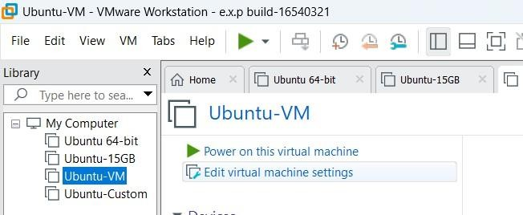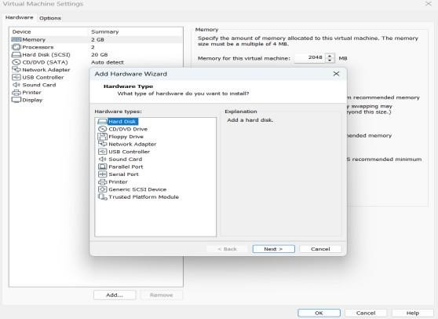

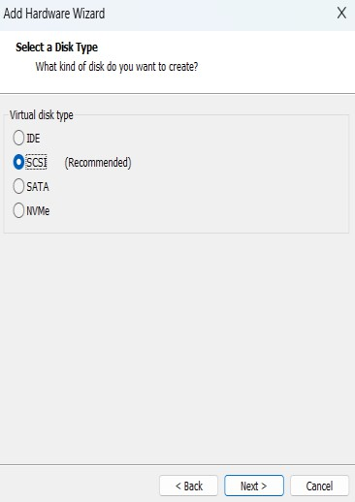
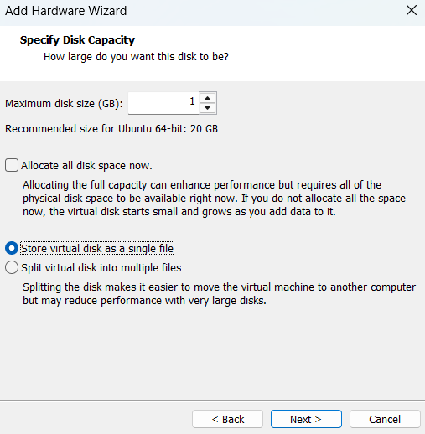
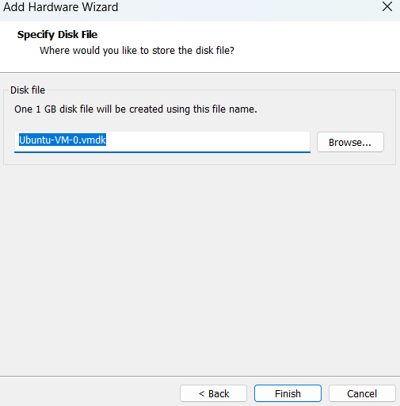

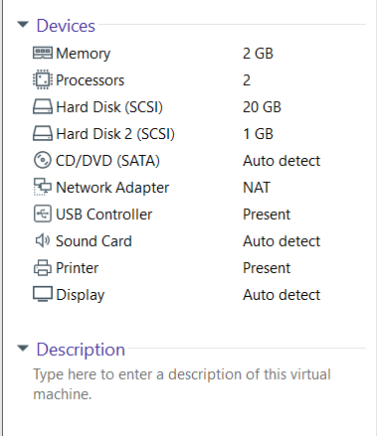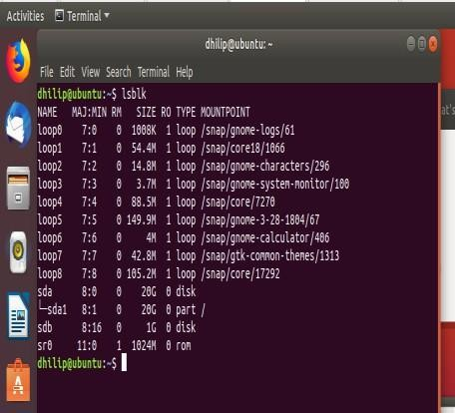
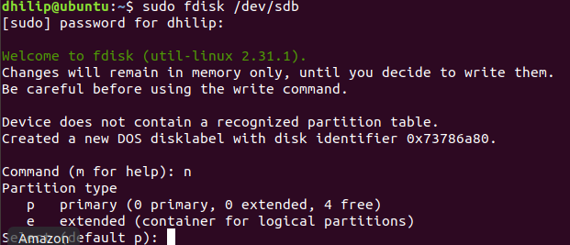
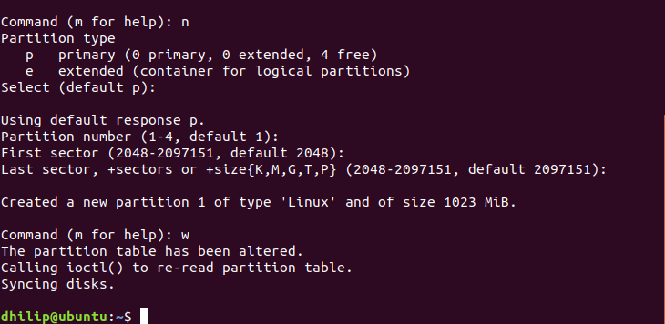
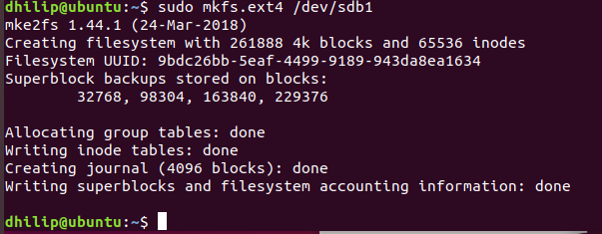

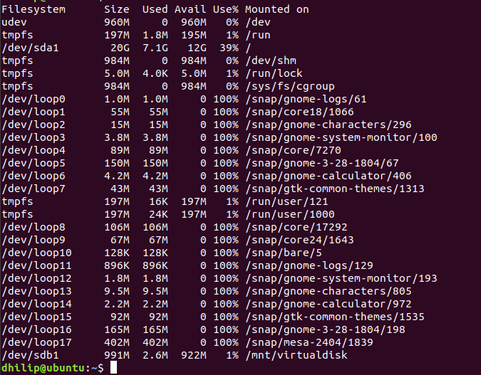
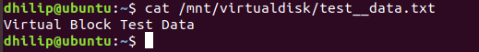
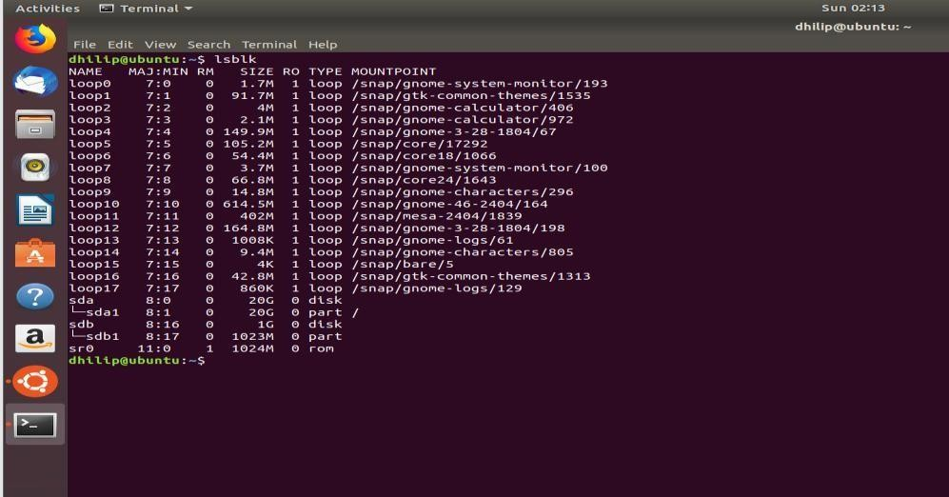

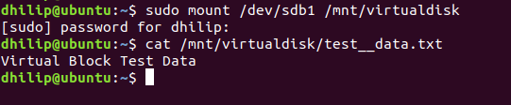

EXP NO 24: To showcase the virtual machine migration based on the certain condition from one host to the other.

Aim:
To demonstrate the migration of a virtual machine from one host/storage location to another using VMware Workstation Pro and verify the migrated virtual machine by executing basic Linux commands.

Procedure:

- Power off the Ubuntu VM properly from Ubuntu.
- Close VMware Workstation Pro.
- Open File Explorer and navigate to: C:\Users\ADMIN\Documents\Virtual Machines
- Locate the original VM folder: Ubuntu-VM
- Copy the complete Ubuntu-VM folder.
- Paste it in the same location and rename the copied folder as: Ubuntu-VM-Migrated
- Open VMware Workstation Pro.
- Select:
File → Open
- Navigate to:

C:\Users\ADMIN\Documents\Virtual Machines\Ubuntu-VM-Migrated

- Select the file with type:
VMware virtual machine configuration (.vmx).
- Click Open.
- VMware displays:
—Did you move or copy this virtual machine?‖
- Select:
I Copied It
- Click OK.

- Power on the migrated Ubuntu virtual machine.
- After Ubuntu starts, open the Terminal using: Ctrl + Alt + T
- Verify the migrated VM using: hostname
- Check the Linux system information using: uname -a
- If the Ubuntu VM starts successfully and the commands execute correctly, the migration is successfully demonstrated.

Implementation:
